13 July 2021

Dear Parent/Carer

This week, the Government announced that it would press ahead with plans to move England to Step 4 from 19th July as part of the roadmap for easing COVID-19 restrictions. The 19th July was chosen as a date as many schools nationally close for the summer term on this day. The thinking is that with schools closed for the summer there is an opportunity to reduce the spread of the virus.

As not all Halton schools break up on the 19th July, I am recommending that Halton schools maintain the current arrangements for a few days after 19th July, until schools close for the summer break.

The situation in Halton and across the North West is that we have rising case rates with spread of the Delta variant. We are managing high case numbers in our schools, with several schools and early years settings experiencing outbreaks. Though the vaccine reduces the risk of someone becoming seriously unwell with COVID-19 it does not eliminate it, so with rising case rates we are expecting more hospital admissions and more people experiencing long-term symptoms of COVID-19 (“long COVID”). We must act to protect our population.

For schools and early years settings, we are asking that that they continue with the current set of protective measures and processes until the end of the summer term. This means:

Prevention measures
- Social distancing
Schools and early years settings continue to facilitate social distancing for staff and pupils in classrooms and communal areas. This will include staggered start and end times.
- Bubbles
Schools and early years settings maintain bubbles for staff and pupils to minimise the number of contacts of any cases of COVID-19.
- Face coverings
For schools with students in year 7, face coverings should be worn by adults and students when moving around the premises, outside of classrooms, such as in corridors and communal areas where social distancing cannot easily be maintained.
In primary schools, face coverings should be worn by staff and adult visitors in situations where social distancing between adults is not possible. Children in primary school do not need to wear a face covering.

- Trips, sports and other event
I continue to advise against school trips, inter-school sporting events, sporting or leavers’ events with spectators, residential trips and most transition visits.
Case and outbreak management
I am asking schools and early years settings to:
- Please continue with current arrangements for self-isolation of symptomatic children. Families should report positive results to school.
- Please continue to identify contacts of staff and pupils who have tested positive for COVID-19 and ensure they self-isolate and do not attend school.
- Schools should continue to report all positive cases (both rapid lateral flow tests and PCR tests) to the LA
- Remember that if you (or your child) have been in contact with someone with COVID-19, you will need to isolate for ten days, regardless of any test results you might get.
Other important measures
- All adults are now eligible for vaccination
- Continue twice-weekly rapid testing for COVID-19 for secondary aged students. If you are a parents of primary aged child you may also choose for your child to participate in the tests arrangements by using our test centres or home tests. Additional information can be found here: No symptoms COVID-19 testing (halton.gov.uk)
- Anyone with a positive rapid lateral flow test should self-isolate with their household and get a PCR test (that is sent to the lab) to confirm the result. These must be booked online at https://www.gov.uk/get-coronavirus-test

- Testing results should be reported via the NHS online reporting system. Results should also be reported to school (schools may have their own systems in place for reporting results).

Many thanks for your understanding.

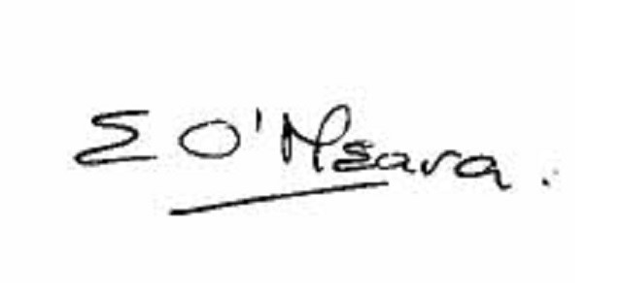
Eileen O’Meara, Director of Public Health and Health Protection

