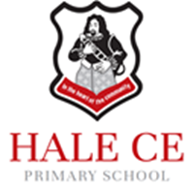
Head Teacher
Mrs Emma Fenton
Head.hale@halton.gov.uk
Telephone: 0151 425 3023

Hesketh Road
Hale Village
Liverpool
L24 4AN
Hale.halton.sch.uk

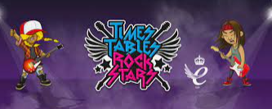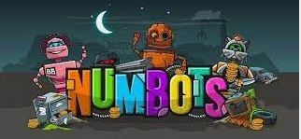

Dear Parents and Carers,

We are excited to inform you that our school has purchased a subscription to the online partner programmes ‘TTRockstars’ and ‘Numbots’.

Numbots is a programme that will help pupils from Reception to Year 6 to improve their knowledge of number bonds and improve mental recall of addition and subtraction facts.

TTRockstars will help pupils from Year 2 to Year 6 to improve their speed and accuracy at times tables and their related division facts.

With this in mind, next Wednesday 15th September, we will be holding a non-uniform launch day. If children from Years 2 to 6 would like to style their hair or clothing similar to that of a rock star they are more than welcome, however, please do not purchase any items specially for this day.

On this day, your child will be introduced to the above programme(s) and will engage in a variety of themed activities. Your child will then bring home a letter with information for parents and carers as well as their individual log in details.

Your support is very much appreciated.
Thank you,

Mrs Herd

